How do you say that?

Ballet terms come from the French language and whilst you may understand what your teacher normally says in class, it may be a little confusing seeing it written down.

If you are struggling to read one of the ballet terms, try copying and pasting in Google.

PC: Ctl C then Ctl P

Mac: Command C then Command P

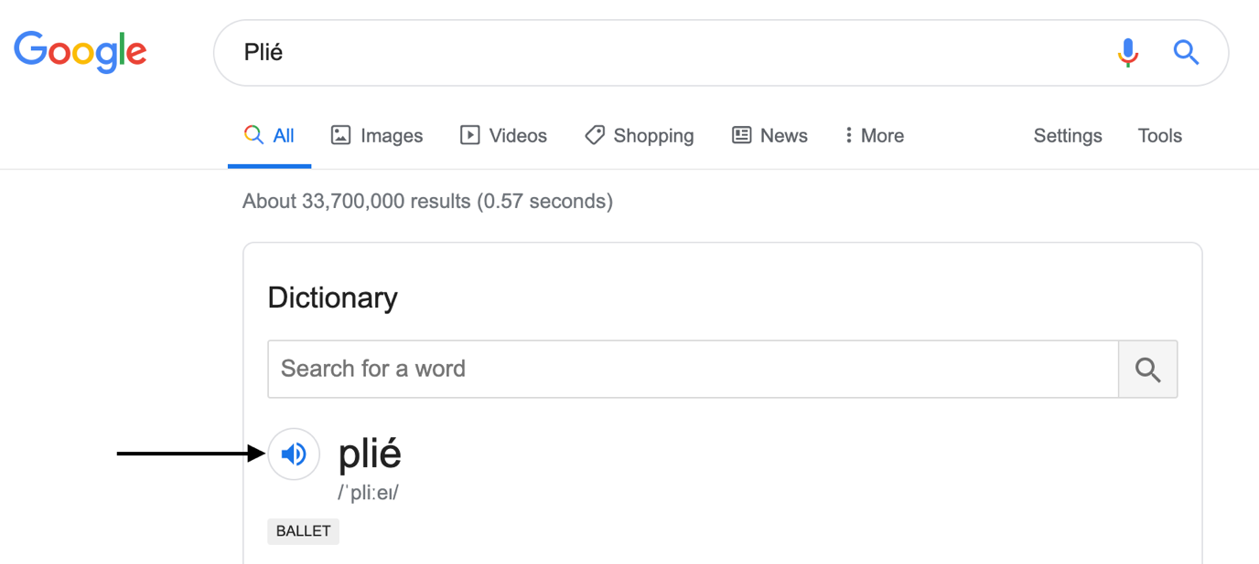

Then click on the sound icon, and you’ll hear the word said out loud.

