The Australian Ballet – Read, Research & Be Inspired!

Read “Meet Artistic Director, David McAllister AM”

https://australianballet.com.au/artist/david-mcallister

Image: David McAllister AM, Australian Ballet website

What city is David originally from?

What year did David join the Australian Ballet as a dancer?

McAllister is the longest serving Artistic Director for the Australian Ballet and will be finishing at the end of 2020. What year did he become Artistic Director?

Make a list of chorographers that David worked with in his role as Artistic Director.

Write down some dot points of facts that interest you about David McAllister. You are welcome to research more widely via a google search.

Bonus: David has an AM at the end of his name, which stands for his contribution to the Australian community. What does it say he received the award for? Click the link to find out!

(https://honours.pmc.gov.au/honours/awards/1056039)

Once complete please email to: serenadeballetacademy@gmail.com

For further inspiration, watch the Sleeping Beauty, which was produced by David McAllister.

Visit the Australian Ballet website (https://australianballet.com.au/) and click through to the 2020 Digital Season [All free to watch].

The Sleeping Beauty is available to watch until Friday 17 April.

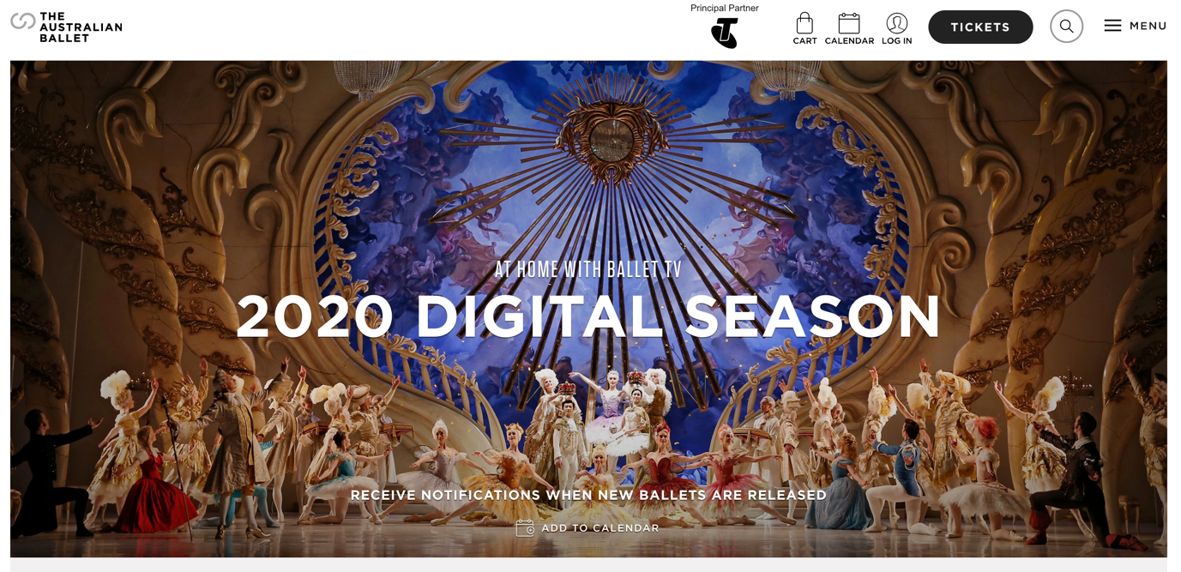
Image: 2020 Digital Season, Australian Ballet website

